# Experiment-3.2

## Student Name: Nabha Varshney UID: 20BCS4995

**Branch: CSE Section/Group: 20BCS-DM-704 (A)**

## Semester: 6th Date of Performance: 5thMay 2023 Subject Name: Data Mining Subject Code: 20CSP- 351

**Aim** – To perform the regression analysis using R programming.

## Objective-

* Represent the reading of file using R studio
* Displaying the graph using linear regression.
* Demonstration of regression analysis by linear regression.

**Script and Output-**

**Regression Analysis Code-**

# Generate random IQ values with mean = 30 and sd =2

IQ <- rnorm(40, 30, 2)

# Sorting IQ level in ascending order

IQ <- sort(IQ)

IQ

# Generate vector with pass and fail values of 40 students

result <- c(0, 0, 0, 1, 0, 0, 0, 0, 0, 1,

1, 0, 0, 0, 1, 1, 0, 0, 1, 0,

0, 0, 1, 0, 0, 1, 1, 0, 1, 1,

1, 1, 1, 0, 1, 1, 1, 1, 0, 1)

# Data Frame

df <- as.data.frame(cbind(IQ, result))

# Print data frame

print(df)

# Plotting IQ on x-axis and result on y-axis

plot(IQ, result, xlab = "IQ Level",ylab = "Probability of Passing")

#Linear regression

lrm <- lm(result ~ IQ)

summary(lrm)

#find the result of a person with IQ 35

a<-data.frame(IQ=35)

predRes<-predict(lrm,a)

print(predRes)

# Create a logistic model

lgm = glm(result~IQ, family=binomial, df)

# Summary of the regression model

summary(lgm)

# Create a curve based on prediction using the regression model

curve(predict(lgm, data.frame(IQ=x), type="resp"), add=TRUE)

**Outlier detection-**

#creating the data containing 500 random values

data <- rnorm(500)

print(data)

#adding 10 random outliers to this data.

data[1:10] <- c(46,9,15,-90,42,50,-82,74,61,-32)

#draw boxpolot and an outlier is defined as a data point that is located outside the whiskers of the box plot.

boxplot(data)

#remove the outlier of the provided data boxplot.stats() function in R

data <- data[!data %in% boxplot.stats(data)$out]

#draw boxplot to verify whether ouliers removed or not

boxplot(data)

**Output-**

**Regression Analysis-**

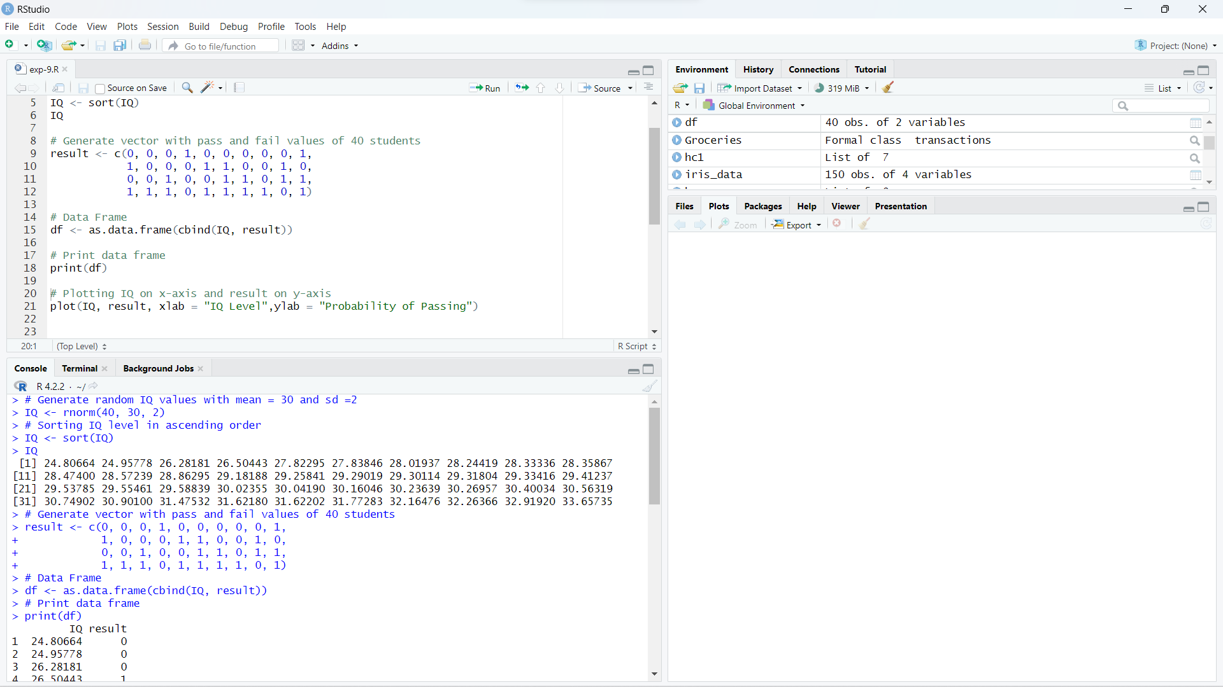

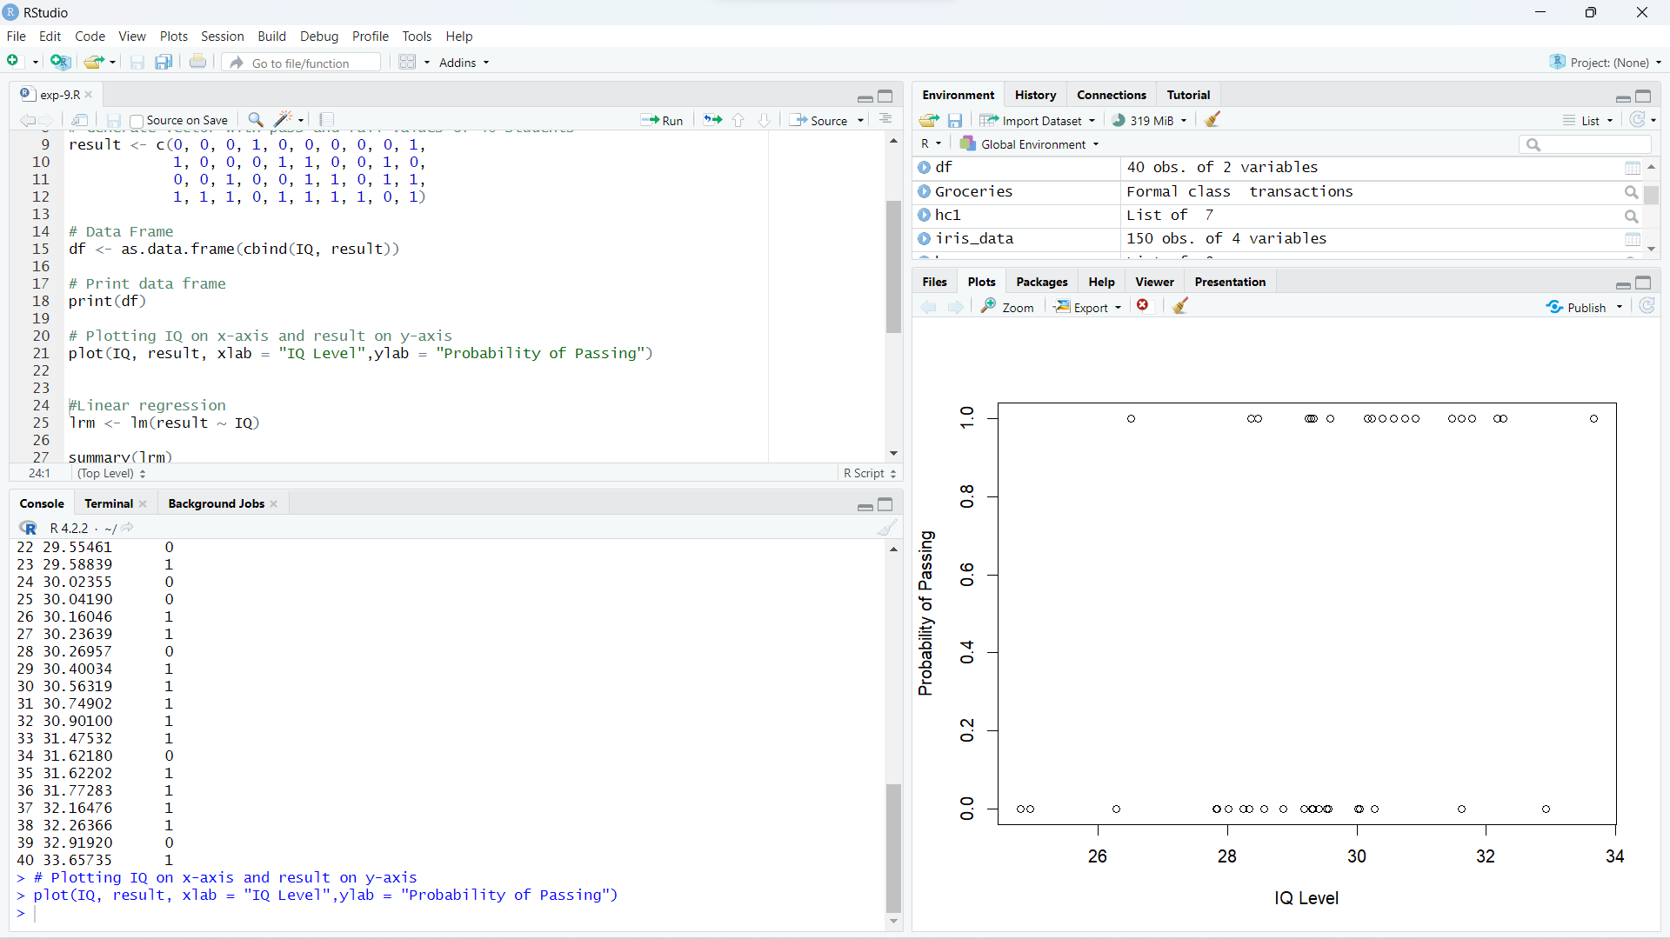

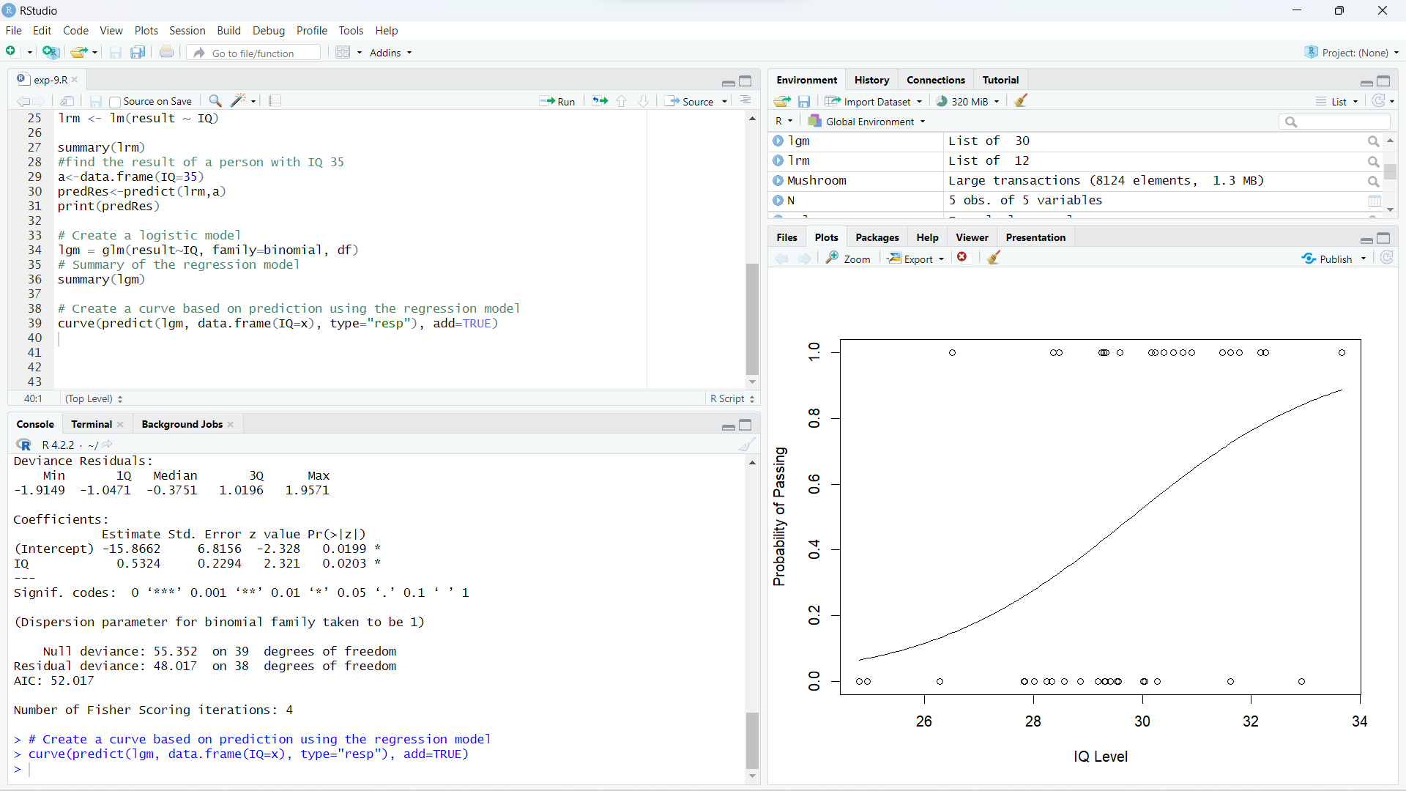

**Outlier detection-**

